Order Of Service

Singing: Psalm 84—CW page 96

Reading: Psalm 40

Opening Hymn: TLH 411

Reading: Acts 1:12-26

Request Hymn: CW Supplement 702

Reading: John 9:35-41

Sermon Hymn: TLH 409

Sermon Text: Song Of Solomon 7:1a

Feet With Shoes

Prayer

The Apostles’ Creed, TLH page 12

Holy Communion

The Lord's Prayer

The Blessing

Closing Hymn: TLH 400

* * * * * * * * * * *

Koinonia Hour



Journey Home

Water
Of
Life

4 June 2017

W A T E R O F L I F E

Independent Christian Church—Conservative Lutheran Doctrine

Worship Service: 9:30 a.m. Bible Study: 10:45 a.m.

Larry Cooper, Pastor E-Mail address:
111 N. Ridge Road lcooper@wateroflife.cc
Coon Valley, WI 54623 Web Site:
Phone: (608) 452-2105 www.wateroflife.cc

* * * * * * * * * * * * * * * * * * * * * * * * * * *

Sermon Text: Song Of Solomon 7:1a

Feet With Shoes

* * * * * * * * * * * * * * * * * * * * * * * * * * *

Song Of Solomon 7:1a How beautiful are thy feet with shoes, O prince’s daughter!

Related Readings: Exodus 3:1-6

1 Now Moses kept the flock of Jethro his father in law, the priest of Midian: and he led the flock to the backside of the desert, and came to the mountain of God, even to Horeb.
2 And the angel of the LORD appeared unto him in a flame of fire out of the midst of a bush: and he looked, and, behold, the bush burned with fire, and the bush was not consumed.
3 And Moses said, I will now turn aside, and see this great sight, why the bush is not burnt.
4 And when the LORD saw that he turned aside to see, God called unto him out of the midst of the bush, and said, Moses, Moses. And he said, Here am I.
5 And he said, Draw not nigh hither: put off thy shoes from off thy feet, for the place whereon thou standest is holy ground.
6 Moreover he said, I am the God of thy father, the God of Abraham, the God of Isaac, and the God of Jacob. And Moses hid his face; for he was afraid to look upon God.

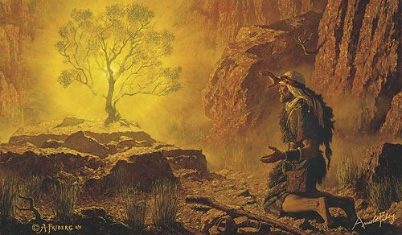

John 13:3-5, 8

3 Jesus knowing that the Father had given all things into his hands, and that he was come from God, and went to God;
4 He riseth from supper, and laid aside his garments; and took a towel, and girded himself.
5 After that he poureth water into a bason, and began to wash the disciples' feet, and to wipe them with the towel wherewith he was girded.

8 Peter saith unto him, Thou shalt never wash my feet. Jesus answered him, If I wash thee not, thou hast no part with me.

